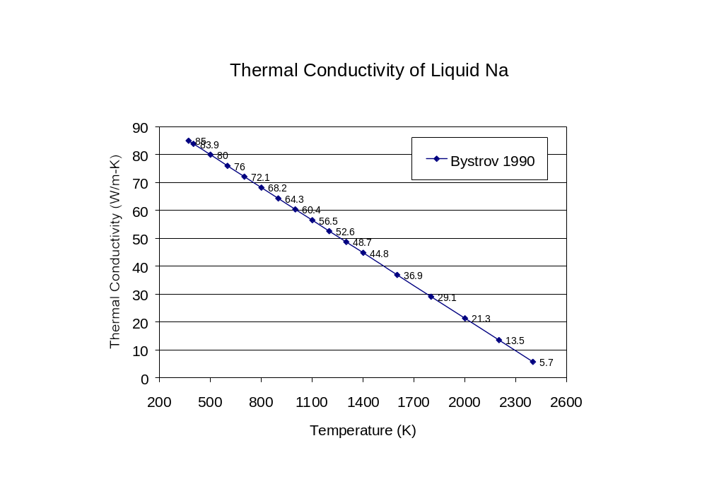
P.I. Bystrov, et al., “Liquid-Metal Coolants for Heat Pipes and Power Plants,” Ed. V. A. Kirillin, Hemisphere Publishing, Corporation, New York, 1990.

